How to Run the Macro
How to Run:
- Get the Drawing List and open up an assembly drawing.
- Then click on the model space prior to running the program. VERY IMPORTANT to bring the model space into focus.
- Click on the toolbar and run the macro.

If you do not click on the model space immediately before running the macro, the view for the drawing will change. It will zoom out to infinity. You will then need to press CTRL + PAGE UP and then CTRL + PAGE DOWN for the view to be restored to its correct settings.

You should be able to see the assembly – and only the assembly - in the model.

How to Install the Macro

1. Save all the Macros (i.e. the .CS files) to the correct location

I am sending you three .CS files. At the moment, save them anywhere on your computer. e.g. in the Documents folder.

The three macros are the following:
- FitToView.cs
- ShowOnlySelected.cs and finally
- FitWorkareaToSelectedParts.cs

Explanation: The last macro: FitWorkareaToSelectedParts is what calls the exe file. This exe file then calls the other two macros: Fit to View and ShowOnlySelected. All three need to be called in order for the program to work.

1. Save the exe file to a particular place on the computer. This should be where ALL the Tekla exe application files go.

- Record the name of the path.

On my computer it is located here, but on your computer, it will be located somewhere else:

C:\Users\Koshy\Documents\Visual Studio 2013\Projects\ShowingAssembliesFromAssemblyDrawings\ShowingAssembliesFromAssemblyDrawings\bin\Debug

- Copy the file path location of the exe application file. It WILL NOT be in the above location. The above location is particular to my computer. The .exe file on your computer will be saved somewhere else.

2. Change the path which currently exists in the FitWorkAreatoSelectedParts.cs file

I have sent you three .cs files. Save them anywhere on your computer. Now open up

Right click and open with notepad:

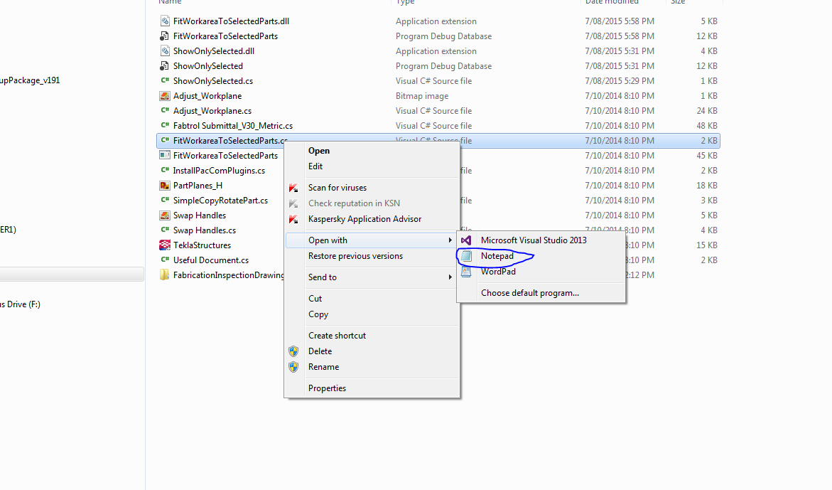

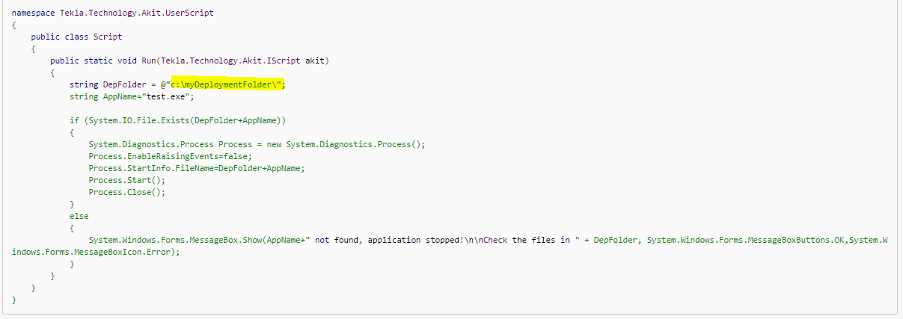
See the highlighted bit?

This is important: Paste the file path in between the following marks:

@”paste-file-path-between the red characters shown here e.g. c:\ShowingAssembliesFromAssemblyDrawings.exe“;

3. Save all the Macros (i.e. the .CS files) to the correct location

Save these two macros: ShowOnlySelected.cs and FitWorkareaToSelectedParts.cs to the following location:
C:\ProgramData\Tekla Structures\19.1\Environments\australasia\macros\modeling

Save the FitToView.Cs file in the below location:
C:\ProgramData\Tekla Structures\19.1\Environments\australasia\macros\drawings

The last macro: FitWorkareaToSelectedParts is what calls the exe file. This exe file then calls the other two macros: Fit to View and ShowOnlySelected.

4. Add a toolbar button in Tekla which runs the FitWorkareaToSelectedParts.cs macro

5. When you want to run the application, all you have to do is use the toolbar which calls the FitWorkareaToSelectedParts or you can run the macro directly by going to Tools → Macros → FitWorkareaToSelectedParts (remember to have the model space in focus before running the macro).

